**Sentiment analysis of review data with blockchain security**

***#1*** *Barathkumar L,* ***#2*** *Gowtham Prasad S,* ***#3*** *Naveen B,* ***#4*** *Mrs Lekha J*

*Department of Computer Science*

*Sri Krishna Arts and Science college, Coimbatore, India.*

**Abstract:** E-commerce has developed hugely in the past years, as such, its regulations have become one of the most important research areas in order to implement a sustainable market. The analysis of a large amount of reviews data generated in the business process can be used to facilitate regulation: since the review data is short text and it is easy to extract the features through deep learning methods. Through these features, the sentiment analysis of the review data can be carried out to obtain the users’ emotional tendency for a specific product or a business. Regulators can formulate reasonable regulation strategies based on the analysis results. However, the data has many issues such as poor reliability and easy tampering at present, which greatly affects the outcome and can lead regulators to make some unreasonable regulatory decisions according to the results. Blockchain provides the possibility of solving these problems due to its transparency and unmodifiable features. Based on these, the blockchain can be applied for data storage, and the Long short-term memory (LSTM) network can be employed to mine reviews data for emotional tendencies analysis. In order to improve the accuracy of the results, we designed a method to make LSTM better understand text data such as reviews containing idioms. In order to prove the effectiveness of the proposed method, different experiments were used for verification, with all results showing that the proposed method can achieve a good outcome in the sentiment analysis leading to regulators making better decisions.

**Introduction**

With the development of e-commerce, a large number of products and its corresponding reviews have been generated. The analysis of reviews data can provide a basis for regulation. In addition, it solves many problems such as descriptions about the product on the website when it does not match the actual object. Due to the fact that the reviews contain emotional information, the sentiment analysis of reviews not only provides references for consumers, but also enables business people to objectively recognize the advantages and disadvantages of their products. Thus, the emotion analysis of reviews has good commercial value as well as playing an important role in many researches.

Sentiment analysis is also called review mining or opinion mining, which aims at identifying, extracting and organizing the emotions contained in text data collected from social applications, blogs, tweets, reviews and others. Most traditional sentiment analysis methods are based on sentiment knowledge, which uses some existing sentiment dictionaries and language technologies can meet these challenges well. It has powerful computational models that improve the many tasks of sentiment analysis including sentiment classification of sentences [7], sentiment extraction and lexicon learning [8]. However, it still cannot solve some problems that currently exist in data analysis, such as weak data source reliability, data being easily tampered with, and asymmetric permissions for data access. These problems will greatly affect the accuracy of the analysis results.

Blockchain provides a to solve these problems. The distributed feature of the blockchain network means each node has equal possibility permission and can share the data. This means that every transaction information can be recorded in the block-chain after the transaction is finished, where it cannot be tampered with and it is open to all nodes in the entire network. The data recorded on it can be considered as a reliable source of reference information, because of the transparent feature. In addition, the blockchain network can also record the information of every link involved in the whole transaction process, which provides an effective basis for the implementation of regulation.

Motivated by these, we propose a sentiment analysis method for review text combining blockchain and a deep learning model to provide regulatory basis and strategy. Blockchain is used to record transactions information and review data after the transactions have finished. Review data like some containing idioms may cause analysis errors can also be well stored in the blockchain. Its features such as complete, non-tamper-able and fully shared can provide reliable data for sentiment analysis. Here, sentiment analysis is conducted by a Long Short-Term Memory (LSTM) network since it has great performance in text analysis, and has been verified in the experiments. The highlights of this research can be divided into two parts.

* In order to ensure the authenticity and validity of the data, a platform based on blockchain has been developed for data storage. Users can make transactions and post related review information through this platform.
* According to the results of sentiment analysis, the proportion of negative reviews can provide a basis and strategy for regulation. The case study proves the effectiveness of the method used for market regulation.
* The remaining structure of the paper: The related work is discussed in Section 2. Section 3 presents the Existing system/method. Proposed system is described in section 4, Section 5 demonstrates the Framework of the system implementation and experiment in section 6 and a Conclusion followed by Future works in Section 7.

**Existing system:**

In order to improve the precision of sentiment analysis, the LSTM model has been improved by an external memory component to process review data containing idioms. Compared with the currently widely used models such as Count Vectorizer and Naive Bayes (NB), the improved model shows better performance.

**Proposed system:**

# Framework

As a data hosting platform, blockchain can ensure the reliability of data due to its distributed and tamper proof features. Therefore, these trustworthy data can be used to feed the improved LSTM for data analysis to obtain creditable results, which is very important for regulation. In essence, the blockchain relies on modern P2P technology to achieve decentralized data sharing and storage. This feature enables any node in the network to view and access the data in the blockchain.

The proposed method mainly involves three types of entities: users/stakeholders, processors and regulators. Based on these three types of entities, the method mainly includes three modules, which are transaction execution and review completion, sentiment analysis and regulation based on the results. Based on these modules, the details of these entities can be described as follows.

Every transaction between nodes consists of a consensus among stakeholders. This function provides a more flexible and easier framework for the system we want to develop. The decentralized system runs on a blockchain-based virtual machine, allowing users to independently evaluate transactions and receive feedback about transactions through smart contracts triggered by the transactions. It can meet the needs of the users more quickly, and can integrate the work of regulatory agencies into existing systems at the lowest cost, which is more effective.

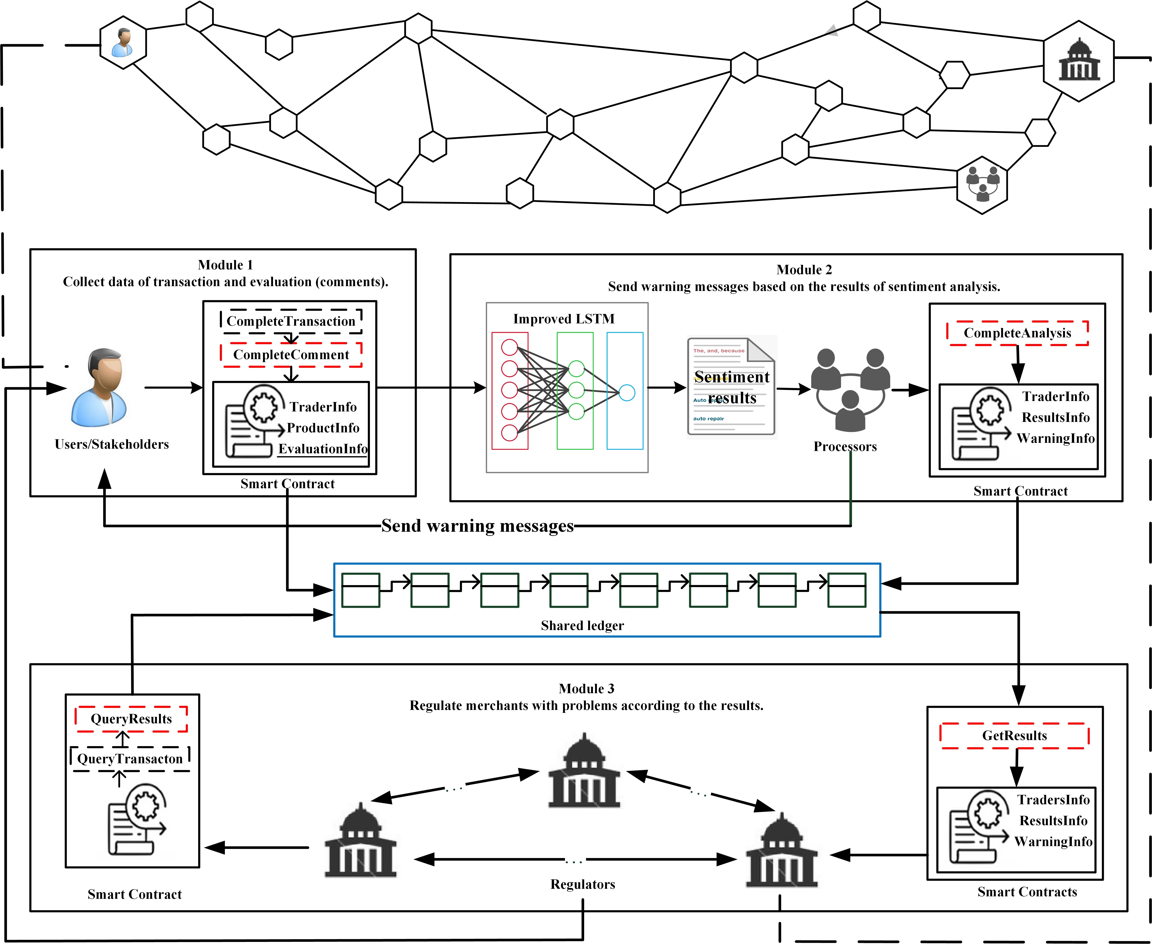

In Sentiment classification there are four different levels of sentiment analysis - sentence level, document level, phrase level, word level

**Implementation and results**

**Conclusion and future works:**

**References:**

1. Sentiment Analysis Using Support Vector Machine Ms. Gaurangi Patil1, Ms. Varsha Galande2, Mr. Vedant Kekan3 , Ms. Kalpana Dange.
2. [Sentiment Analysis using LSTM. Tech Stack: Python, Scikit-Learn… | by Abishek PSS | MLearning.ai | Medium](https://medium.com/mlearning-ai/sentiment-analysis-using-lstm-21767a130857)
3. Sentiment Analysis of Review Data Using Blockchain and LSTM to Improve Regulation for a Sustainable Market

Zhihua Zhao, Zhihao Hao, Guancheng Wang, Dianhui Mao, Bob Zhang [,](https://orcid.org/0000-0003-2497-9519) Min Zuo, Jerome Yenand Guangjian Tu

<https://www.mdpi.com/0718-1876/17/1/1/htm>